Mover produccion a otro campo

select * from twell w

where w.WELL_ID = 1044

COMPANY 1

BATTERY 1043

WELL 1044

NAME ESPERANZA NORTE-1(UP T)

MERAK ESPERANZA_NORTE_01:TSUP

select * from twell w

where w.WELL_NAME like 'Colibri%'

COMPANY 1

BATTERY 936

WELL 1044

NAME Colibri 6(UP T)

MERAK COLIBRI_06:TSUP

select * from tdaily_well_tnx t

where t.WELL_ID = 1044

select * from twell_specs ws

where ws.WELL_ID = 1044

select * from twell_status wst

where wst.WELL_ID = 1044

select * from twell w

where w.WELL_ID = 1044

***************************

BATTERY_ID FROM 1043 TO 936

update twell w

set w.BATTERY_ID = 936

where w.WELL_ID = 1044

update tdaily_well_tnx t

set t.BATTERY_ID = 936

where t.WELL_ID = 1044

update twell_specs ws

set ws.BATTERY_ID = 936

where ws.WELL_ID = 1044

update twell_status wst

set wst.BATTERY_ID = 936

where wst.WELL_ID = 1044

update tpm_pump_efficiency_interface p

set p.BATTERY_ID = 936

where p.WELL_ID = 1044

delete tpm_pump_efficiency_interface p

where p.WELL_ID = 1044

and p.BATTERY_ID = 936

commit

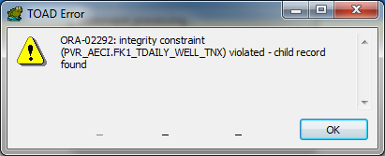

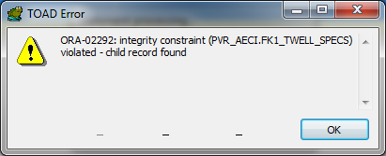

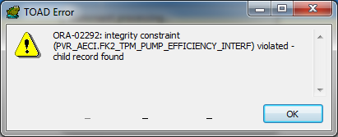

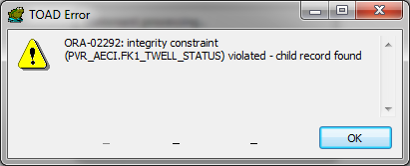

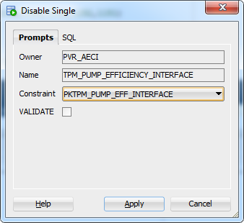

PEDIDO DE LA ARCH movimiento de Mariann Sur a Mariann Battery

Wellids involved 1143,1116,1145,1132,1146,1149,1152,1151

update twell w

set w.BATTERY_ID = 29

where w.BATTERY_ID = 1112

update tdaily_well_tnx t

set t.BATTERY_ID = 29

where t.BATTERY_ID = 1112

update twell_specs ws

set ws.BATTERY_ID = 29

where ws.BATTERY_ID = 1112

update twell_status wst

set wst.BATTERY_ID = 29

where wst.BATTERY_ID = 1112

update tpm_pump_efficiency_interface p

set p.BATTERY_ID = 29

where p.BATTERY_ID = 1112